Project #7: Explain IP Subnetting Worksheet

Section 1 /24 Network
Network Address: 192.168.4.0
Broadcast Address: 192.168.4.255
Available Hosts: 254
First Assignable Host: 192.168.4.1
Last Assignable Host: 192.168.4.254

Section 2 /25 Subnet 1
Network Address: 192.168.4.0
Broadcast Address: 192.168.4.127
Available Hosts: 126
First Assignable Host: 192.168.4.1

Section 2 /25 Subnet 2
Network Address: 192.168.4.128
Broadcast Address: 192.168.4.255
Available Hosts: 126
Last Assignable Host: 192.168.4.254

Section 3 /26 Network
Subnet 1 Network Address: 192.168.4.0
Subnet 2 Network Address: 192.168.4.64
Subnet 3 Network Address: 192.168.4.128
Subnet 4 Network Address: 192.168.4.192

Section 4 /27 Network (answer these questions for the 5th subnet in the network)
Subnet 5 Network Address: 192.168.4.128
Subnet 5 Broadcast Address: 192.168.4.159
Available Hosts: on Subnet 5: 30
First Assignable Host on Subnet 5: 192.168.4.129
Last Assignable Host on Subnet 5: 192.168.4.158

Section 5 – Subnetting Scenario
Subnet the given network to meet the given host requirements.

Network: 192.168.110.0/24
Department | Hosts | Subnet Size | CIDR | Network | Subnet Mask | Sort Order
Sales | 80 | 128 | /25 | 192.168.110.0 | 255.255.255.128 | 1
Advertising | 35 | 64 | /26 | 192.168.110.128 | 255.255.255.192 | 2
Research | 18 | 32 | /27 | 192.168.110.192 | 255.255.255.224 | 3
Marketing | 11 | 16 | /28 | 192.168.110.224 | 255.255.255.240 | 4
Administration | 6 | 8 | /29 | 192.168.110.240 | 255.255.255.248 | 5
Router->Router | 2 | 4 | /30 | 192.168.110.248 | 255.255.255.252 | 6
CEO | 2 | 4 | /30 | 192.168.110.252 | 255.255.255.252 | 7

Screenshots
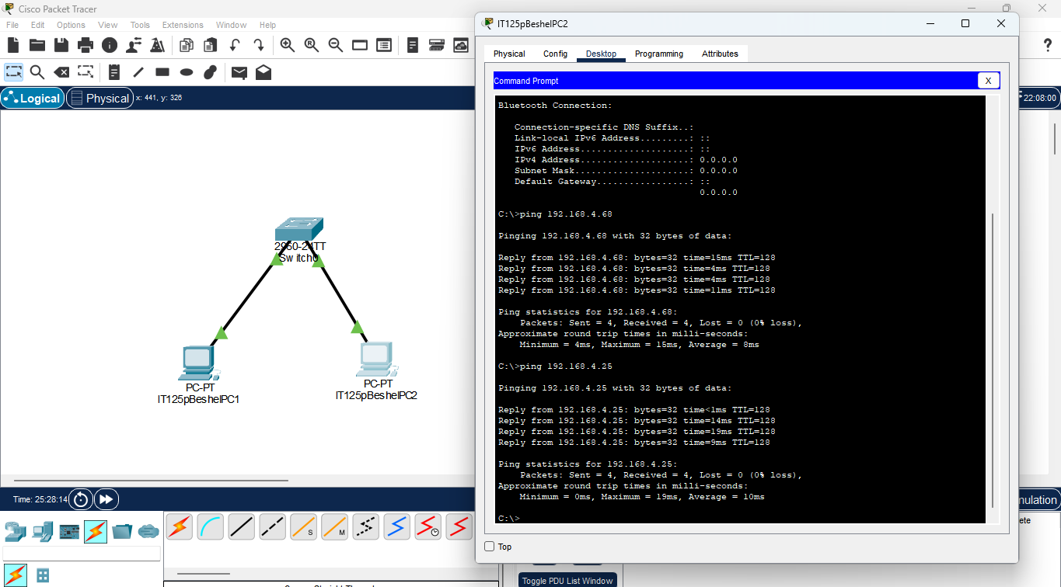

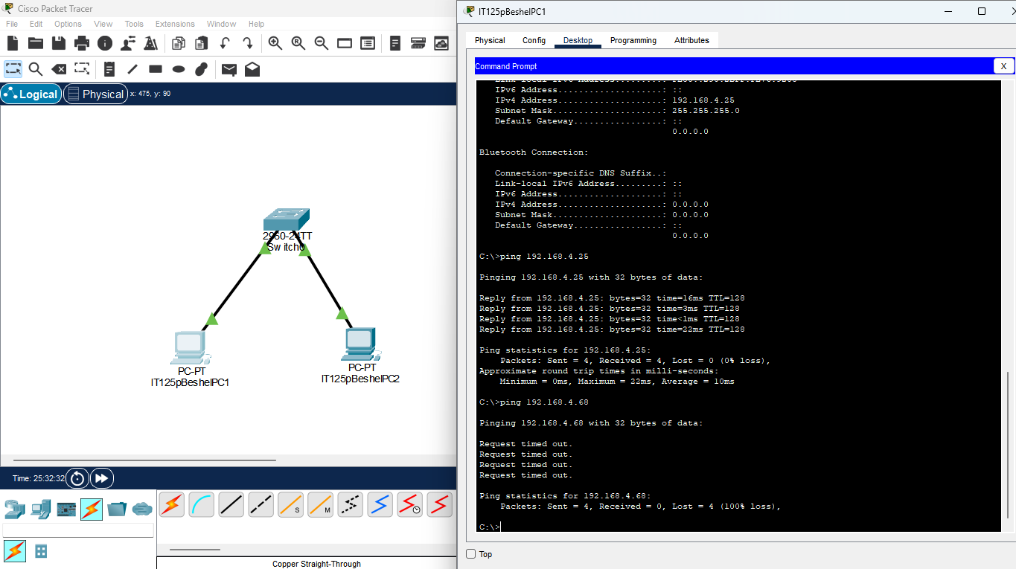

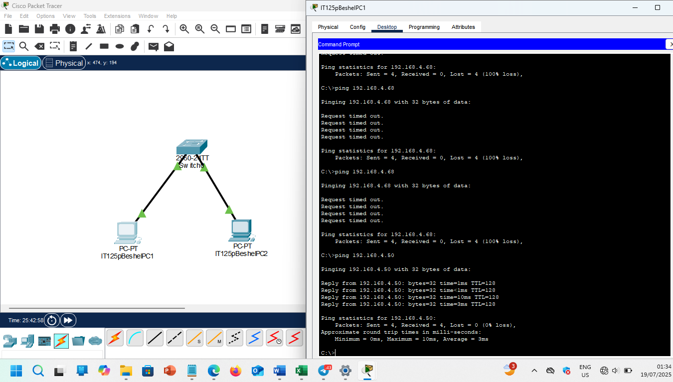

Question: What did you do to allow successful PING between the 2 computers?
I changed the IP address of IT125pBeshelPC2 to 192.168.4.50, to put it in the same subnet as IT125pBeshelPC1 i.e. in the 192.168.4.0/26 subnet.

